**Performance Optimization Report**

**Introduction:**

**Stay organized and boost your productivity with our easy-to-use To-Do List application. Whether you need to track daily tasks, work projects, or personal goals, this tool makes it simple to manage everything in one place.**

**Key Features:**

* **Create Tasks: Add new tasks quickly and easily.**
* **Delete Tasks: Remove tasks you’ve completed or no longer need.**

**Initial Analysis:**

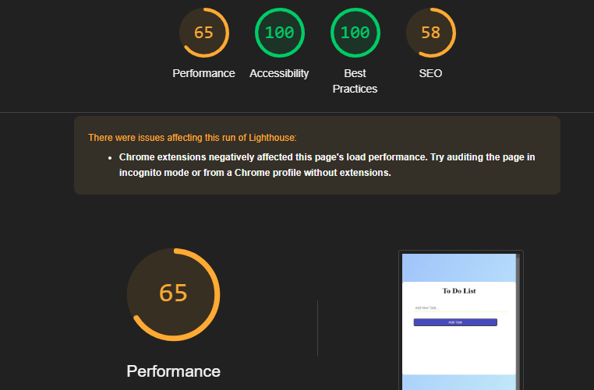

**Key issues:**

* **Unused JavaScript**
* **Unused CSS**
* **Large Contentful Paint element**

**Optimization Steps:**

**Steps I take to optimize my website**

* **Add meta tags for better SEO**
* **Remove the unused CSS**
* **Used inline CSS where needed**
* **Add defer in the Script tag for better loading**
* **Remove unused JavaScript**

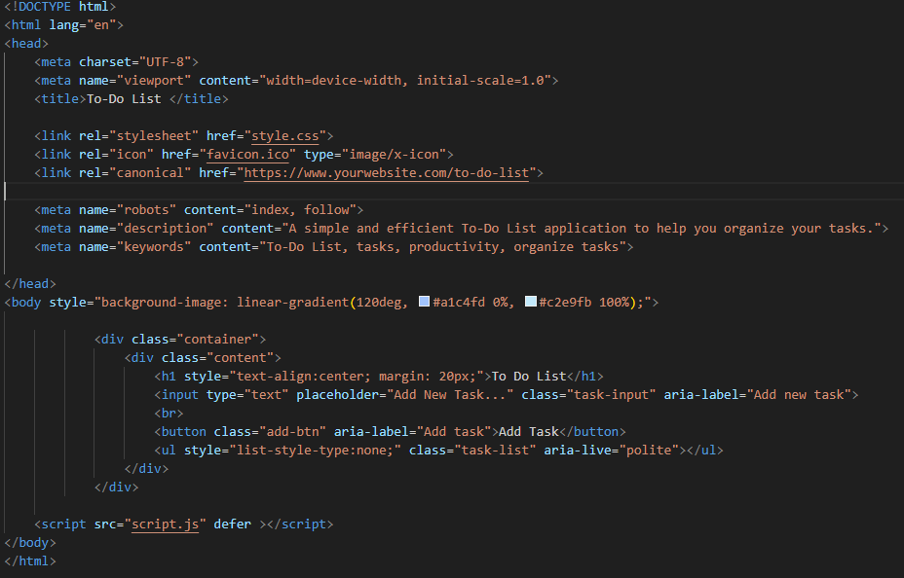

**Final Analysis:**

**Here is the result after the optimization of my website**

* **The performance is now better, it increases from 65 to 84.**
* **The SEO has increased from 58 to 63.**

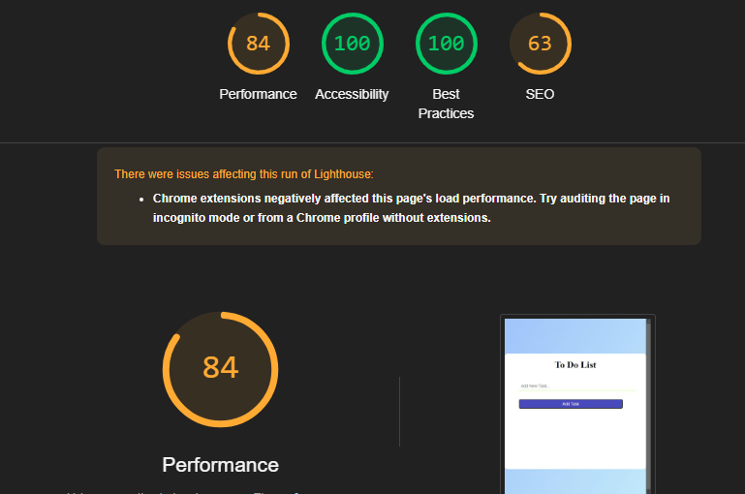

**Conclusion:**

**After implementing targeted optimizations, I significantly improved my To-Do List web application's performance. Using Google Lighthouse, I increased the performance score from 65 to 84, demonstrating a marked enhancement in speed and responsiveness. Additionally, I raised the SEO score from 58 to 63, ensuring better visibility and search engine rankings.**

**These improvements not only enhance user experience but also contribute to a more efficient and accessible platform for managing tasks**